General information about the Municipality of Ruma
INVESTORS GUIDE

Local Economic Development of the Municipality of Ruma


2019

The Municipality of Ruma
Department for Local Economic Development
15.08.2019.

Area of the Municipality of Ruma : 582 km²
Population : 54.339
17 communities
74% agricultural land, 13% the forest,13% other
Ethnic structure : 21 nationalities
Number of enterprices: 512
Number of entrepreneurs : 1,560

Key sectors
- Agriculture
- Automobile industry
- Leather and footwear industry
- Textile industry
- Than: rubber industry, construction materials, metal, graphic and food processing, transport, trade, crafts and catering.

Ruma is a regional center of Srem district. It's well-developed municipality that offers to it's citizens a high quality life:

- Quality social and health care, excellent education service toenhance people's lives, adequate cultural and tourist facilities and high a level of security, stimulated by a healthy economy and facilitated by well-coordinated, effective and efficient local self-government.
- Full support for thriving communities in our municipality that is a regional distribution center and the leader in organic food production, equipped with the required facilities for food processing and marketing.
- We are a regional centre for the education and further training of the necessary workforce to offer all interested investors an adequate, trained and skilled workforce and equipped industrial sites on favourable terms.
- The best services that not just meet but exceed the citizens' needs, rendered by the modernized local self-government that works closely with the residents in the decision-making process by taking into account their inputs and suggestions.
- The community profile served as the basis for setting four strategic priorities, based on which goals were defined, from which program and project proposals were created and an action plan was defined.

Strategic position of the Municipality of Ruma
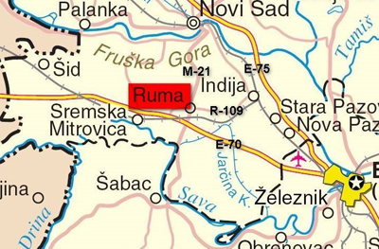
The Municipality of Ruma has an excellent geostrategic position:
- (highway E-70), railway Beograd -Zagreb- Beč (27km)
- the main highway M21
- Visinity of the harbor in Sremska Mitrovica (15km)
- Viciniti of the harbor in Šabac (35km)
- Visinity of the international airport ,,Nikola Tesla"(35 km)
- Ruma is located between two University centers, Beograd (50 km) and Novi Sad (35 km).
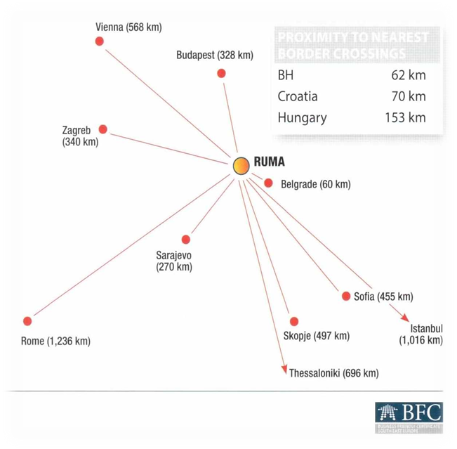

Reasons for investing in Municipality of Ruma

There are several factors that create a favorable business climate for the economic
development of the Municipality of Ruma:
- excellent geographical and geostrategic position
- adequate infrastructure and reliable utilities
- skilled labor, land (5 industrial zones) and construction costs at competitive prices
- favorable fees for landscaping and furnishing office space
- developed institutional capacity
- excellent investment potential and willingness to meet investor needs.

The Municipality implements a transparent tax policy
and a tax collection policy that stimulates economic development
- The Municipality defines and adopts decisions on local fees and charges in a transparent manner (conducts public hearings on draft decisions),
- The opinion of the private sector is taken into account through the Economic Council, the Socio-Economic Council, the Employers Union and other less formal forms of communication.
- The municipality offers relief to the economy, for the most part this area is regulated by the relevant republic laws, and the municipality of Ruma within its jurisdiction regulates the property tax coefficient for the territory of the municipality, as well as the average prices per square meter of property for determining property tax for 2019.
BUILDING PERMITS
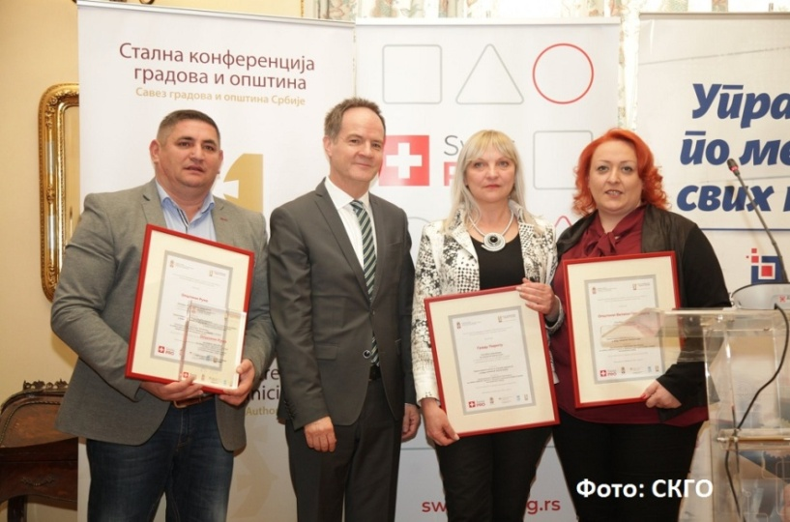
A system of services for obtaining a building permit
The Ministry of Construction, Transport and Infrastructure and NALED awarded the Award to the Municipality of Ruma for its outstanding contribution to the implementation of the electronic licensing system and was ranked fourth in the category of the most efficient municipalities in Serbia by the number of resolved and positively resolved investor requirements (success rate 85.14%).
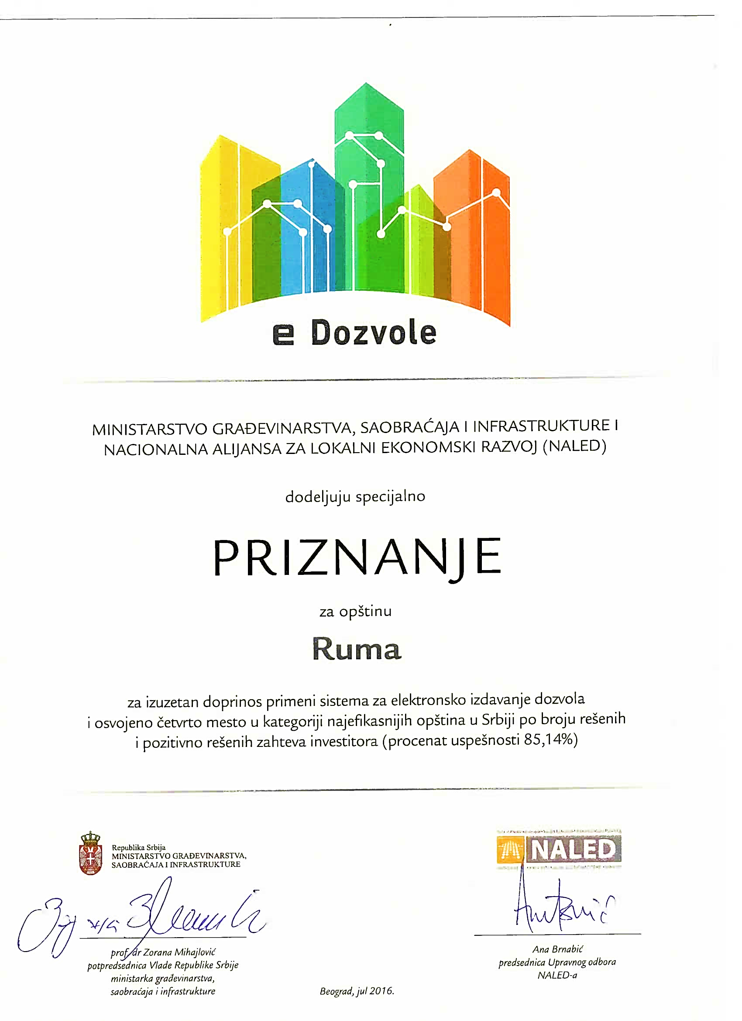

Examples of good practice
- Through practice, the Municipality of Ruma has proven that it is possible to make an investment in the short term.
- HUTCHINSON realized its investment in less than 6 months
- Building permit issued September 09, 2015
- The grand opening was on February 27, 2016
- The company is expanding its production capacity year by year and increasing the number of employees.
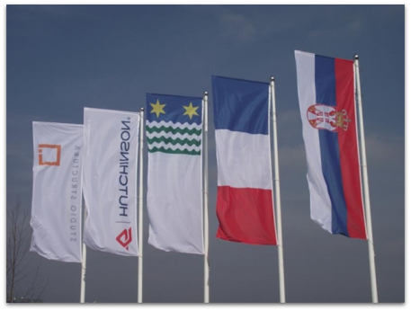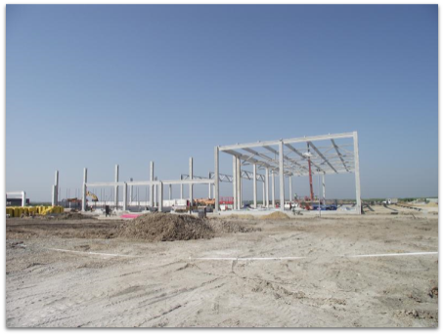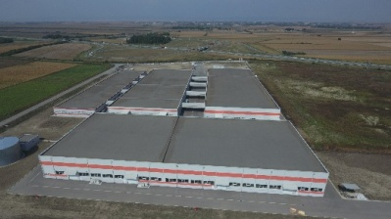
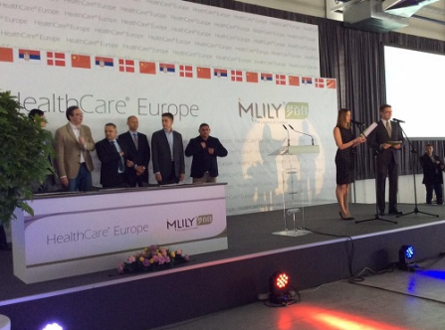

- HEALTH CARE EUROPE realized it's investment in 10 months
- The building permit was issued on August 06, 2014
- The grand opening was on June 28, 2015
- Continuous development of the company.

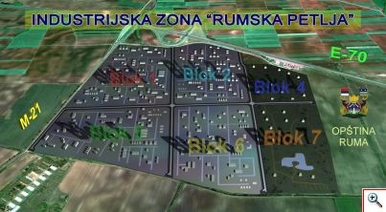RUMSKA PETLJA

AREA: The total land available for sale is 1,529,417 m2. The type of land is construction, while the property is the Municipality of Ruma.
LOCATION: The work zone "Rumska Petlja" covers an area of 240 ha, in a good strategic position, with a distance of 50 km from Belgrade, 35 km from Novi Sad and 35 km from international airport. Located between state road I A of line no. 3 and country road I B of line number 21. Vicinity of the markets of the countries of the region Croatia, Bosnia and Herzegovina, Hungary and Romania. High spatial potential for inflow of new direct investments on the remaining 153 ha of available work zone land.
EXISTING COMPLEXES: "HealthCare Europe", "CG Foods Europe", "Rumekon", "Srbijaautoput", "Rumetal Trade".
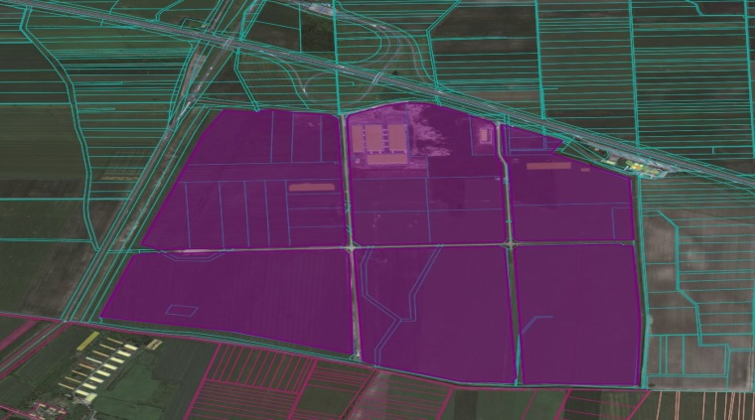
WORKING ZONE EAST
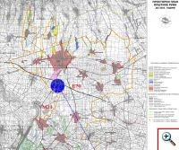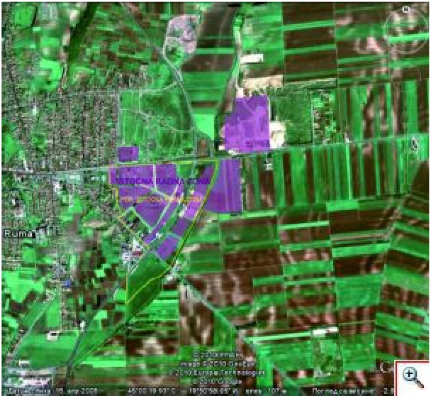AREA: 425.000 m², accounting 3,91 % of all work zones in K.O. Rumа.
PROCESSED PDR-om: 400.000 m², which is 75 % of the total area of the WORKING ZONE EAST
(PDR “working zone east” Službeni list Sremа br. 21/06).
Work area 40 ha in construction area
LOCATION: It is located in the eastern
part of the city which is accessible from the
main highway M21 and regional roads R-106
and R-103. It extends along the bypass road
M-21, from the intersection with industrial
Industrial Street south, to the Dumps zone nort
with the eastern boundary coinciding with
the boundary of the construction site
(IGM excavation site at edge area) and west,
which is generally defined by parts street:
15. Avgusta, Jelenacka, Glavna, Kraljevačka.

EXISTING COMPLEXES: "Vasarište", "IGM", "Prometal", "Frigo Zika-Soko Ruma", gas station "Knez-petrol", "Matesic", transport, "Agrar FM", "Rumekon", "Eurotom", "Ferroplet", "Agropromet", gas station "Avis-gas".
WORKING ZONE EAST has previously planned to develop and complete the tertiary works program with coal. New potentiation is not foreseen, the business complex is extremely possible business condition (1 to 2 degrees within individual complexes, and humid is required).
General Plan envisages that the destruction plans may be decomposed into the whole zone, or parts there of as spatially functional units; larger, new and complex journals are defined by the complex will be developed by the UPR, and the lesser benefits will be the use of privileges and conditions from the General Plan itself, that is, regulations and norms with a specific area.

WORK ZONE WEST
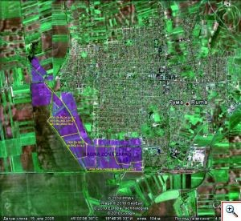
AREA: 1,950,000 m², accounting for 17.95% of all work zones in K.O. Ruma PDR treated: 970,000 m², which is 49.74% of the total area. It covers about 20 hectares in the construction area.
LOCATION: Traffic access to the zone is made possible from the regional roads R-103 and R -106. (existing Industrial Zone) is a whole that extends along part of Stejanovac Road to the west and along and on both sides of Industrial Street to Ul. Of Vladimir Nazor southwest / south.
EXISTING COMPLEXES: "Agroglobe", "Albon", "Hutchinson", "Insert", "M&V Partner Concrete" "AMC Afrodite Mode Collection", "IGM-West", "Vulin Commerce", "Rumen", "Mitas-Trelleborg" "," Menina "," Rumaplast "," Fixa Shoes "," Andric company, "Dag co," Radun Avia "," Alba promet ", "Meltal recycling ",
" Jakob Becker ".

PLANNED ACTIVITIES:

This zone should be developed to accommodate larger complexes of less clean industry on the south side of Industrial Street, on the north side of the location of tertiary activities (“small” economy) with a belt of protective greenery towards the residential area.

The traffic backbone is Industrial Street, the South Road (South Industrial Street) is planned, parallel to the railway and the connecting road at "Novogradnja", while the intersection of other roads will be determined by the development plans. The existing housing can be maintained and reconstructed, the new one is not planned, except for business housing (1-2 apartments within individual complexes, for the needs of the owner).

Existing industrial complexes can be expanded, supplemented with new plants, possibly changing the production program, plants need to be modernized, production to be upgraded, infrastructure upgraded or reconstructed, road and parterre offices, environmental protection measures and other measures are provided.

The GP envisages that the entire plan, possibly parts of the zone as a spatially functional unit, be obliged to elaborate with a detailed plan.

WORKING ZONE NORTH

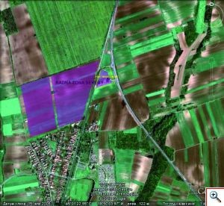
AREA: 190,000 m², accounting for 1.75% of all
work areas in K.O. Ruma TREATED BY PDR:
30,000m², 15.79% of the total area of the
NORTH WORKING ZONE (PDR "Iriški drum"
Službeni list Srema Br. 14/02).
LOCATION: Areas east of the Irig road and west
along the northern part of the Iris road - junction
with M -21do Park Forest along Borkovac the lake,
bounded by the intersection of the intersection
zone with M -21 and the northern bypass, the
corridor of the M -21 road.

EXISTING COMPLEXES: "MG - petrol" gas station.
EQUIPMENT: Road around the gas pipeline system - YES
PLANNED ACTIVITIES: Trade, catering and transportation.
WORKING AREA NORTH is an extended work zone in the northern part of Ruma that is planned because of its attractive location. It is planned that in this area of business will be developed and completed economic activities in the field of primarily commercial (larger trade facilities) and catering activities (restaurants, apartments, hotels ), then tourism (rehabilitation, health, wellness & spa), sports and recreation (sports fields) , different types of parks . Considering that it is the "Novi Sad" entrance with valuable landscape features, where the "Donnera" plantation is located in the north, then it leans on the Borkovačka valley with which it is connected with an uncategorized route, within which it would be good to plan three trails, to direct pedestrian paths and cycling routes.

WORKING AREA SOUTH 1
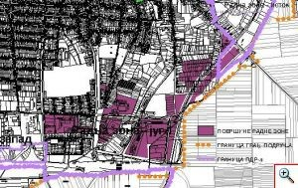
AREA: 500.000 m², which is 4,60 % all work zones in K.O. Ruma
PROCESSED PDR-om: WORKING AREA SOUTH it is not processed PDR-om
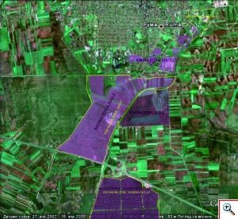
LOCATION: involves the space between street V. Nazora west to the bypass road (M-21)east, from the railway south to Industrial Street, or the Vrbare area north..

EXISTING COMPLEXES: “Andrijаšević”, “Belinа”, “Rumаplаst”, “Quiq”, Elektrodistribucije “Rumа”, i Vаtrogаsne jedinice Autobаze “Borovicа-trаnsport”, “Simićа”, “Agrosemenа” i sklаdištа gorivа “NAP-а”, "Uniprogres", "Luxury Tannery".

The Ruma Railway Station complex is a special and specific work or space-functional unit, it is planned and processed separately, or within the contact area with the city.

PLANNED ACTIVITIES: The main commitment of the GP is that the economic and other facilities of this zone, which is mostly completed, be further edited and improved on the existing complexes, without compromising the functions of the complexes.
No major expansion of these complexes is possible except for minor corrections and spatial relocations. It implies completion of planned and unrealized programs, replacement of programs and technology, expansion, reconstruction, modernization of production, service and other capacities, upgrades of road and other infrastructure, with mandatory implementation of environmental and other protection measures. No construction is permitted between the M-21 / Rail loop. New housing is not foreseen, commercial housing is extremely possible in commercial complexes (1-2 flats within individual complexes, for the needs of the owner). The GP foresees that detailed plans can be used to elaborate the whole zone, or its sub-units, but since the complexes are mostly defined and that they will be practically supplemented and reconstructed on the basis of specific programs, urban conditions will, for more complex interventions at individual locations, complexes, as a rule to determine through the development of urban projects; for smaller works, which do not interfere with the overall conception of the GP and (or) general conditions of realization of the wider environment, using the rules and conditions from the GP itself, that is, regulations and norms for a particular activity.

WORKING ZONE SOUTH 2

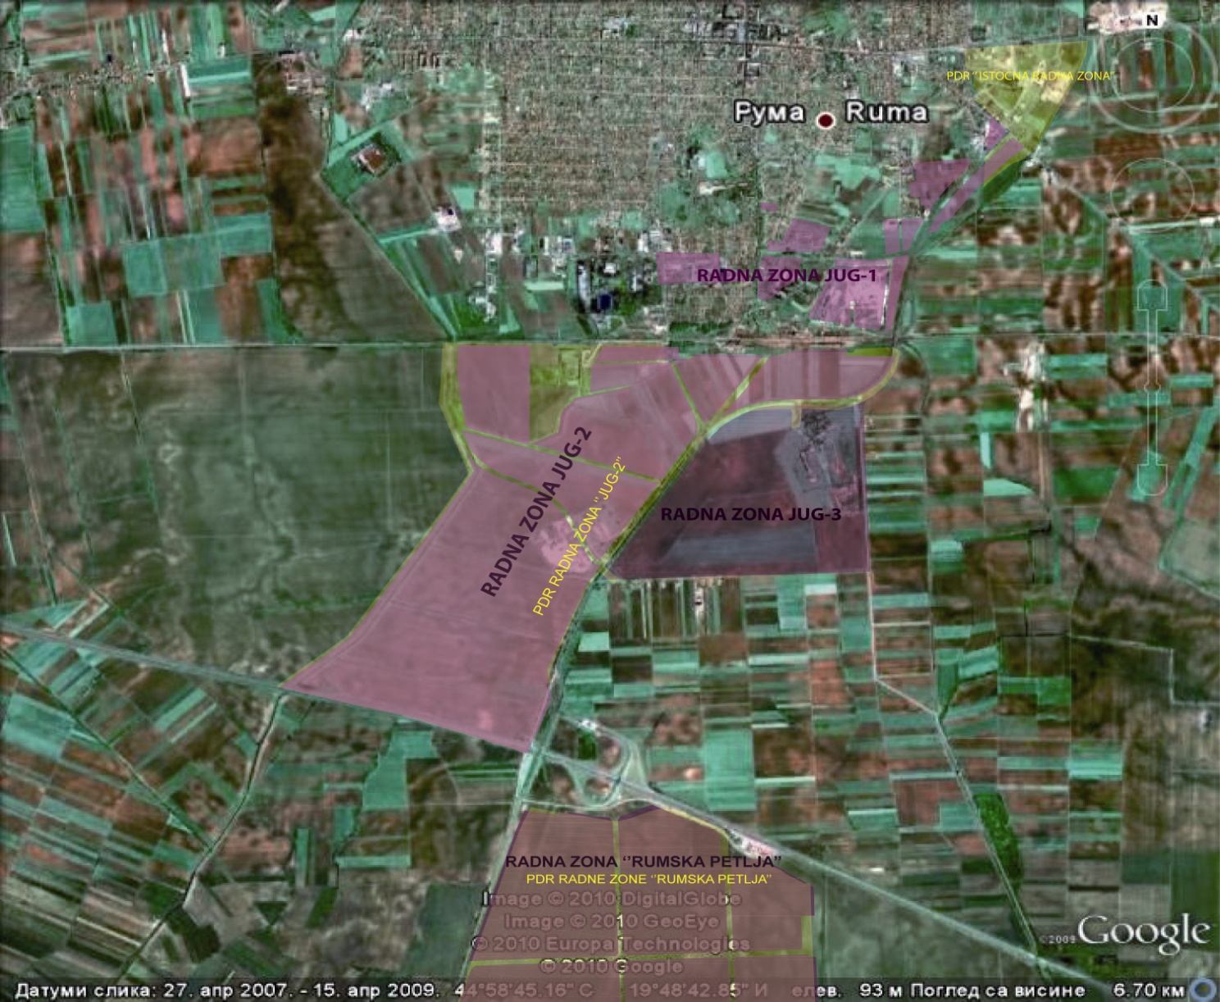

AREA: The total land area is 983,589 m2, while the surface of the buildings is 2629 m2.
It implies the area south of the line bordering the Belgrade-Zagreb railway line, the Kudoš / Jelenci canal corridors, and the junction of the M-21 junction (extension of V. Nazor Street) all along and within the boundary of the construction area. It was formed between the border of the construction zone from the north, the M-21 main road from the east, the Belgrade-Zagreb Highway (E-70) from the south, and from the west the border of the Municipality of Ruma.
LOCATION: Working zone South 2 covers an area of ​​390 ha, in a good strategic position, with distance of 50 km from Belgrade, 35 km from Novi Sad and 35 km from Nikola Tesla Airport. The work area is located in Corridor 10 and is therefore attractive due to the vicinity of the markets of the countries of the region.
EXISTING COMPLEXES: Wastewater Treatment Plant (UPOV), "Mesoproduct", "Galenika - Plant Protection", "Sremput", "Hemoimpex". In this zone, it primarily has a possible extension of the WWTP zone (wastewater treatment plant); west of the UPOV site, construction of an impure industrial complex is possible purifier function; to the east of the purifier is the possible location of content of a similar character, with existing economic and technical facilities.
Work Zone South 2 is the largest work zone in K.O. Ruma, which is partly located in the construction area and most of it in the area, for which planning documentation is under construction.

